# Java Class and Objects

Java is an object-oriented programming language. The core concept of the object-oriented approach is to break complex problems into smaller objects.

An object is any entity that has a **state** and **behavior**. For example, a bicycle is an object. It has

* **States**: idle, first gear, etc
* **Behaviors**: braking, accelerating, etc.

Before we learn about objects, let's first know about classes in Java.

## **Java Class**

A class is a blueprint for the object. Before we create an object, we first need to define the class.

We can think of the class as a sketch (prototype) of a house. It contains all the details about the floors, doors, windows, etc. Based on these descriptions we build the house. House is the object.

Since many houses can be made from the same description, we can create many objects from a class.

## **Create a class in Java**

We can create a class in Java using the class keyword. For example,

class ClassName {

// fields

// methods

}

Here, fields (variables) and methods represent the **state** and **behavior** of the object respectively.

* fields are used to store data
* methods are used to perform some operations

For our bicycle object, we can create the class as

class Bicycle {

// state or field

private int gear = 5;

// behavior or method

public void braking() {

System.out.println("Working of Braking");

}

}

In the above example, we have created a class named Bicycle. It contains a field named gear and a method named braking().

Here, Bicycle is a prototype. Now, we can create any number of bicycles using the prototype. And, all the bicycles will share the fields and methods of the prototype.

**Note**: We have used keywords private and public. These are known as access modifiers.

## **Java Objects**

An object is called an instance of a class. For example, suppose Bicycle is a class then MountainBicycle, SportsBicycle, TouringBicycle, etc can be considered as objects of the class.

### **Creating an Object in Java**

Here is how we can create an object of a class.

className object = new className();

// for Bicycle class

Bicycle sportsBicycle = new Bicycle();

Bicycle touringBicycle = new Bicycle();

We have used the new keyword along with the constructor of the class to create an object. Constructors are similar to methods and have the same name as the class. For example, Bicycle() is the constructor of the Bicycle class.

Here, sportsBicycle and touringBicycle are the names of objects. We can use them to access fields and methods of the class.

As you can see, we have created two objects of the class. We can create multiple objects of a single class in Java.

**Note**: Fields and methods of a class are also called members of the class.

## **Access Members of a Class**

We can use the name of objects along with the . operator to access members of a class. **For example,**

class Bicycle {

// field of class

int gear = 5;

// method of class

void braking() {

...

}

}

// create object

Bicycle sportsBicycle = new Bicycle();

// access field and method

sportsBicycle.gear;

sportsBicycle.braking();

In the above example, we have created a class named Bicycle. It includes a field named gear and a method named braking(). Notice the statement,

Bicycle sportsBicycle = new Bicycle();

Here, we have created an object of Bicycle named sportsBicycle. We then use the object to access the field and method of the class.

* **sportsBicycle.gear** - access the field gear
* **sportsBicycle.braking()** - access the method braking()

Now that we understand what is class and object. Let's see a fully working example.

## **Example: Java Class and Objects**

class Lamp {

// stores the value for light

// true if light is on

// false if light is off

boolean isOn;

// method to turn on the light

void turnOn() {

isOn = true;

System.out.println("Light on? " + isOn);

}

// method to turnoff the light

void turnOff() {

isOn = false;

System.out.println("Light on? " + isOn);

}

}

class Main {

public static void main(String[] args) {

// create objects led and halogen

Lamp led = new Lamp();

Lamp halogen = new Lamp();

// turn on the light by

// calling method turnOn()

led.turnOn();

// turn off the light by

// calling method turnOff()

halogen.turnOff();

}

}

**Output**:

Light on? true

Light on? false

In the above program, we have created a class named Lamp. It contains a variable: isOn and two methods: turnOn() and turnOff().

Inside the Main class, we have created two objects: led and halogen of the Lamp class. We then used the objects to call the methods of the class.

* **led.turnOn()** - It sets the isOn variable to true and prints the output.
* **halogen.turnOff()** - It sets the isOn variable to false and prints the output.

The variable isOn defined inside the class is also called an instance variable. It is because when we create an object of the class, it is called an instance of the class. And, each instance will have its own copy of the variable.

That is, led and halogen objects will have their own copy of the isOn variable.

## **Example: Create objects inside the same class**

Note that in the previous example, we have created objects inside another class and accessed the members from that class.

However, we can also create objects inside the same class.

class Lamp {

// stores the value for light

// true if light is on

// false if light is off

boolean isOn;

// method to turn on the light

void turnOn() {

isOn = true;

System.out.println("Light on? " + isOn);

}

public static void main(String[] args) {

// create an object of Lamp

Lamp led = new Lamp();

// access method using object

led.turnOn();

}

}

**Output**

Light on? true

Here, we are creating the object inside the main() method of the same class.

# Java Methods

A method is a block of code that performs a specific task.

Suppose you need to create a program to create a circle and color it. You can create two methods to solve this problem:

* a method to draw the circle
* a method to color the circle

Dividing a complex problem into smaller chunks makes your program easy to understand and reusable.

In Java, there are two types of methods:

* **User-defined Methods**: We can create our own method based on our requirements.
* **Standard Library Methods**: These are built-in methods in Java that are available to use.

Let's first learn about user-defined methods.

## **Declaring a Java Method**

The syntax to declare a method is:

returnType methodName() {

// method body

}

Here,

* **returnType** - It specifies what type of value a method returns For example if a method has an int return type then it returns an integer value.  
    
  If the method does not return a value, its return type is void.
* **methodName** - It is an identifier that is used to refer to the particular method in a program.
* **method body** - It includes the programming statements that are used to perform some tasks. The method body is enclosed inside the curly braces { }.

For example,

int addNumbers() {

// code

}

In the above example, the name of the method is adddNumbers(). And, the return type is int. We will learn more about return types later in this tutorial.

This is the simple syntax of declaring a method. However, the complete syntax of declaring a method is

modifier static returnType nameOfMethod (parameter1, parameter2, ...) {

// method body

}

Here,

* **modifier** - It defines access types whether the method is public, private, and so on.
* **static** - If we use the static keyword, it can be accessed without creating objects.  
    
  For example, the sqrt() method of standard **Math class** is static. Hence, we can directly call Math.sqrt() without creating an instance of Math class.
* **parameter1/parameter2** - These are values passed to a method. We can pass any number of arguments to a method.

## **Calling a Method in Java**

In the above example, we have declared a method named addNumbers(). Now, to use the method, we need to call it.

Here's is how we can call the addNumbers() method.

// calls the method

addNumbers();

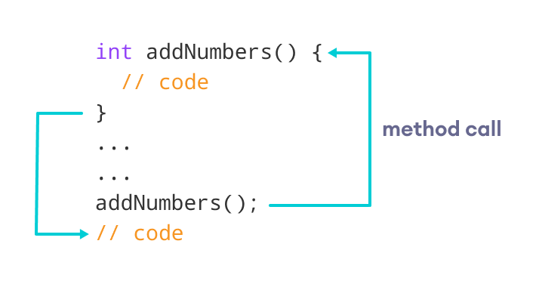Working of Java Method Call

## **Example 1: Java Methods**

class Main {

// create a method

public int addNumbers(int a, int b) {

int sum = a + b;

// return value

return sum;

}

public static void main(String[] args) {

int num1 = 25;

int num2 = 15;

// create an object of Main

Main obj = new Main();

// calling method

int result = obj.addNumbers(num1, num2);

System.out.println("Sum is: " + result);

}

}

**Output**

Sum is: 40

In the above example, we have created a method named addNumbers(). The method takes two parameters a and b. Notice the line,

int result = obj.addNumbers(num1, num2);

Here, we have called the method by passing two arguments num1 and num2. Since the method is returning some value, we have stored the value in the result variable.

**Note**: The method is not static. Hence, we are calling the method using the object of the class.

## **Java Method Return Type**

A Java method may or may not return a value to the function call. We use the **return statement** to return any value. For example,

int addNumbers() {

...

return sum;

}

Here, we are returning the variable sum. Since the return type of the function is int. The sum variable should be of int type. Otherwise, it will generate an error.

### **Example 2: Method Return Type**

class Main {

// create a method

public static int square(int num) {

// return statement

return num * num;

}

public static void main(String[] args) {

int result;

// call the method

// store returned value to result

result = square(10);

System.out.println("Squared value of 10 is: " + result);

}

}

**Output**:

Squared value of 10 is: 100

In the above program, we have created a method named square(). The method takes a number as its parameter and returns the square of the number.

Here, we have mentioned the return type of the method as int. Hence, the method should always return an integer value.

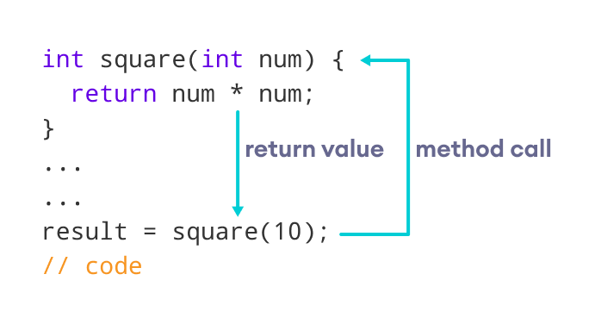Representation of the Java method returning a value

**Note**: If the method does not return any value, we use the void keyword as the return type of the method. For example,

public void square(int a) {

int square = a * a;

System.out.println("Square is: " + square);

}

## **Method Parameters in Java**

A method parameter is a value accepted by the method. As mentioned earlier, a method can also have any number of parameters. For example,

// method with two parameters

int addNumbers(int a, int b) {

// code

}

// method with no parameter

int addNumbers(){

// code

}

If a method is created with parameters, we need to pass the corresponding values while calling the method. For example,

// calling the method with two parameters

addNumbers(25, 15);

// calling the method with no parameters

addNumbers()

### **Example 3: Method Parameters**

class Main {

// method with no parameter

public void display1() {

System.out.println("Method without parameter");

}

// method with single parameter

public void display2(int a) {

System.out.println("Method with a single parameter: " + a);

}

public static void main(String[] args) {

// create an object of Main

Main obj = new Main();

// calling method with no parameter

obj.display1();

// calling method with the single parameter

obj.display2(24);

}

}

**Output**

Method without parameter

Method with a single parameter: 24

Here, the parameter of the method is int. Hence, if we pass any other data type instead of int, the compiler will throw an error. It is because Java is a strongly typed language.

**Note**: The argument 24 passed to the display2() method during the method call is called the actual argument.

The parameter num accepted by the method definition is known as a formal argument. We need to specify the type of formal arguments. And, the type of actual arguments and formal arguments should always match.

## **Standard Library Methods**

The standard library methods are built-in methods in Java that are readily available for use. These standard libraries come along with the Java Class Library (JCL) in a Java archive (*.jar) file with JVM and JRE.

For example,

* print() is a method of java.io.PrintSteam. The print("...") method prints the string inside quotation marks.
* sqrt() is a method of Math class. It returns the square root of a number.

Here's a working example:

### **Example 4: Java Standard Library Method**

public class Main {

public static void main(String[] args) {

// using the sqrt() method

System.out.print("Square root of 4 is: " + Math.sqrt(4));

}

}

**Output**:

Square root of 4 is: 2.0

Please refer below link for the following topics

<https://www.programiz.com/java-programming/class-objects>

|  |
| --- |
| **1. constructors**  **2. access control**  **3. usage of static with data and methods**  **4. usage of final with data**  **5. overloading methods and constructors**  **6. recursion, nested classes** |